Headteacher
Busbridge CE (Aided) Junior School
Brighton Road
Busbridge
Godalming
Surrey
GU7 1XA

Telephone: 01483 417302
Fax: 01483 427852

Email: admin@busbridge-junior.surrey.sch.uk
Website: www.busbridge-junio.surrey.sch.uk
Mr Richard Catchpole BSc (Hons) PGCE NPQ
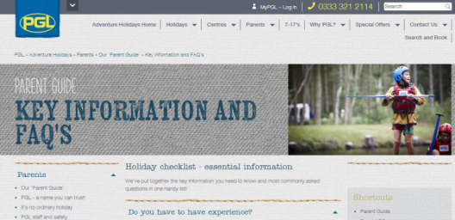
Year 6 Windmill Hill 2024 Kit List
- Walking boots (optional)
- Trainers for general activities
- Footwear that can get wet for water activities (old trainers, rock shoes. Not flip flops, crocs open-toed sandals)
- Swimwear x1 (for raft building activity)
- Socks and underwear for every day plus 2 spare
- Shorts x3 (please make sure that they cover the thighs for activities that involve climbing and harnesses)
- Trousers/ track suit bottoms x3 (no jeans as they will not dry)
- T-shirts/ shirts x 7 (include long sleeved)
- Jumper/ sweatshirt x3
- Sun hat/ sun cream
- Raincoat
- Pyjamas
- Cuddly toy for bedtime
- Towel x2
- Toilet bag with hairbrush, soap, toothbrush, toothpaste etc
- Torch
- Water bottle
- Pocket money £5 (in a named bag 5x £1 coins)
- Reading book
- Packed lunch for the first day in a disposable container. No fizzy drinks.
- Small pack of sweets we can share should children need a ‘lift’.
- Several plastic bags to put wet clothes in.
- Bag/holdall preferably with wheels as the children will carry their own bags
- Wet suits should not be brought as they will not dry!
This is a guide to what to take. Please feel free to amend this as you require for your own child’s needs.
NB. For medicines please refer to the medical form.
Please ensure that everything is named.
All bedding is provided. Safety equipment is provided.
No cameras, phones, electrical devices.
The PGL adventure holidays website has an excellent Parent Guide: Key information and FAQ section
https://www.pgl.co.uk/en-gb/adventure-holidays/parents/our-parent-guide/key-information-and-faqs

